Technical Proposal Submitted to

**Climate Vulnerability and Risk Assessment of the Local Governments**

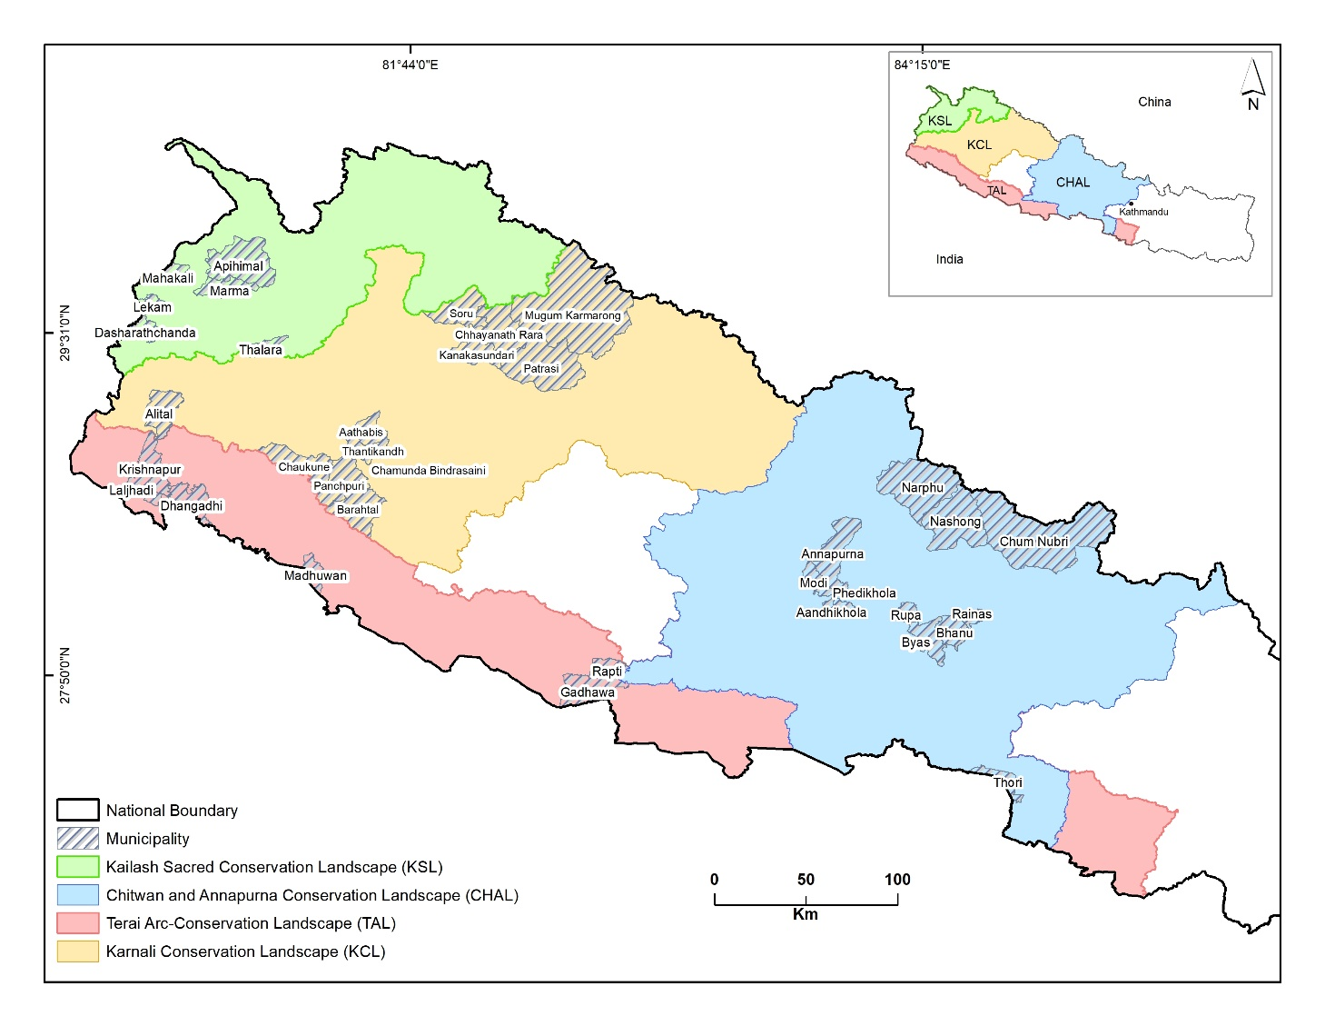**USAID BIODIVERSITY (JAL JANGAL)**

Map of the selected 36 Municipalities for Vulnerability Assessment

Submitted by

**GLOBAL INSTITUTE FOR INTERDISCIPLINARY STUDIES**

March 4, 2024

**Executive Summary**

In response to the Request for the Proposal (#RFP-KTM-24-0048), our team proposes rigorous and innovative approaches for VRA underpinned by the latest data and cutting-edge tools. Both the proposed project team and organization (Global Institute for Interdisciplinary Studies) have unparalleled expertise and experience in social vulnerability and multi-hazard risk assessments. GIIS has worked with USAID-Nepal to conduct vulnerability and risk assessments of 753 municipalities of Nepal, the World Health Organization (WHO) to assess vulnerability of climate-sensitive diseases, and the International Water Management Institute (IWMI) to carry out Water, Sanitation and Hygiene (WASH) sectors’ vulnerability in Dailekh and Sarlahi. The interdisciplinary team comprises a team leader with significant experience in climate change research, VRA analysis and expertise in GIS/RS; a biodiversity and forest expert with experience in climate change; a DRR expert with experience in watershed management; and a GESI expert with experience in social vulnerability. Additionally, the team has a GIS/RS expert who has experience in analyzing large climate datasets and research assistants.

The vulnerability and risk assessment process involves scoping the VRA process, finalizing the VRA framework, identifying and choosing key indicators, collecting data, and standardizing and normalizing the collected data. Furthermore, composite indices for adaptive capacity, sensitivity, and exposure will be developed. A composite multi-hazard index will also be created. The process will be completed in three distinct phases: the preparatory phase, the workshop and consultation phase, mapping of the composite vulnerability and risk phase. During the preparatory phase, the finalization of the vulnerability risk framework, collection, curation and standardization of municipality-scale secondary data for the thirty-six municipalities will be completed. Stakeholders including MoFE, MoFAGA, NARMIN, MuAN, local municipalities, and the USAID biodiversity team will be consulted to finalize the VRA framework and indicators of sensitivity, exposure, adaptative capacity, and hazards. Co-creation workshops and focus group discussions in the selected six municipalities will be held to gather insights from the local stakeholders about the vulnerability and risk in their context and potential adaptation strategies for risk reduction. Based on the consensus framework and indicators, vulnerability and risk maps will be produced at different scales and thematic areas. The results of the VRA assessment will be shared through result-sharing workshops at the municipality level so that the findings will be incorporated into their climate adaptation plans and strategies.

# **Context**

Human-induced climate change has adversely affected every aspect of the earth’s system resulting in extensive losses and damage to people and ecosystems (IPCC 2021). Increasing frequency and intensity of extreme climate events such as drought, extreme heat, floods, and forest fires have already threatened the livelihoods of millions of people particularly those reliant on natural resources (Ebi et al. 2021; Gentle & Maraseni 2012). Climate change has modified ecosystem structure, function and natural adaptative capacity (Botkin et al. 2007; Walther 2010) and caused species range shift (Parmesan & Yohe 2003), population depletion (Koh et al. 2004), phenological change (Parmesan 2006), and alteration of plant-pollinator interactions (Rafferty et al. 2011). Climate change also facilitates the spread of invasive species, diseases and pests which erode the resilience of the ecosystems and species (Hulme, 2017). These adverse impacts of climate change on biodiversity diminish nature’s capacity to provide ecosystem services thereby impacting the well-being of people, particularly those in rural impoverished communities such as Nepal (Mooney et al. 2009).

Nepal is one of the world’s most climate-vulnerable countries, holding 12th rank among 180 countries in the Global Climate Risk Index 2021 (Eckstein et al. 2021). Climate change along with other drivers has impacted Nepal’s biodiversity (Bhattacharjee et al. 2017) and facilitated the spread of invasive species (Shrestha & Shrestha 2019). Concurrently, climate-induced hazards such as flash floods and landslides frequently damage critical infrastructures (IFRC 2021) and disproportionately affect the poor, women, the elderly, and marginalized communities (MoHA & DPNet 2009). Building climate-resilient communities and ecosystems has become a national priority in Nepal (GoN, 2021). The Local Government Operation Act (2074) mandates municipalities prepare disaster/risk-sensitive land use planning. However, a conspicuous gap persists in comprehending the vulnerability of both ecosystems and communities at risk at the local level of government. While recent government-led vulnerability and risk assessments in Nepal (MoFE 2021) have been conducted at the district level, there remains an indispensable need to extend such assessments to the municipality and ward levels. The current call of the USAID Biodiversity program aims to fulfill the gaps and the program’s objective (enhancing the climate resilience of natural and human ecosystems) by undertaking a comprehensive Climate Vulnerability and Risk Assessment (VRA) within 36 municipalities.

# **Approach, detail methodology and intervention plan**

## Literature review

A comprehensive review of available literature (research articles, census and survey reports, vulnerability and risk reports published by government agencies, development partners, and non-governmental organizations) related to different sectors and cross-cutting sectors of vulnerability and risk assessments will be conducted.

## Scoping of Vulnerability and Risk Assessment (VRA)

The research team will develop a preliminary VRA framework. We will follow VRA frameworks from the Fifth Assessment Report (AR5) of the Intergovernmental Panel on Climate Change (IPCC) (IPCC 2014), VRA framework of Nepal’s Forests, Biodiversity and Watershed Management sector adopted by Nepal’s government (MoFE 2021b). We will consult with the Climate Change Management Division (CCMD) at the Ministry of Forests and Environment, the Planning and Foreign Aid Coordination Division (Environment and Disaster Management section) within the Ministry of Federal Affaire, and General Administration (MoFAGA) for technical guidance and internalizing the VRA process and outcomes. We will follow the IPCC definition that defined the ‘risks from climate change' are the function of interactions between exposures to climate-related hazards, sensitivity, vulnerabilities of exposed population and natural systems, and adaptive capacity of the health systems to manage risks (IPCC 2007; IPCC 2014).

## Finalizing the VRA framework

A preliminary framework developed by the scoping work of our expert team will be shared during the co-creation workshops. Co-creation workshop will be organized by inviting stakeholders, including representatives of the donor community working in the project areas, the Association of International Non-Governmental Organizations, Civil Society Organizations (CSOs), National Association of Rural Municipalities in Nepal (NARMIN), Municipal Association of Nepal (MuAN) and the Association of District Coordination Committees of Nepal (ADCCN), local government officials, federal ministries, and regional universities. In the co-creation workshop, the expert team will also outline key challenges, threats, and risks relevant to climate change in Nepal’s biodiversity, agricultural and watershed sectors, and identify local concerns, and needs. A preliminary set of data collected from secondary sources and indicators for VRA will also be presented to identify and select appropriate indicators based on their significance at the local level.

## Identification and selection of key indicators

The study team will conduct a comprehensive exploration of data and indicators from various sources, including the indicators used in the previous studies (e.g., Williamson et al., 2007; MoPE 2010; Macchi 2011; ADPC 2013; Birkmann et al. 2013; Chaulagain et al. 2015; Pandey & Bardsley 2015; Wise et al. 2016; Mainali and Pricope 2017; MoPE, 2017b; Jha et al. 2018; Aksha et al. 2019; Azhar and Varidona 2019; Walker et al. 2019; FAO & CIFOR 2019; Chhetri et al. 2020; SADC 2020; GIIS 2020; GIIS 2021; MoFE 2021a; MoFE 2021b; Giri et al. 2021). After incorporating the feedback from the co-creation workshop participants, a final list of indicators will be prepared.

## Data collection

Based on the scope, and rationale of the study, as well as the local needs and priorities, we will explore the data to the relevant indicators (or proxies) for different themes and sectors.

Data on social, political (institutions), economic, physical, environmental, and human will be acquired from census, relevant ministries, government agencies, development partners as well as global datasets.

We will collect data on incidences, losses, and damages from the hazards from the BIPAD portal (<https://bipadportal.gov.np>) and DesInventar Sendai data (<https://www.desinventar.net/>). The DesInventar provides data from 1971 to 2013 and BIPAD portal has data from 2011 to now). Spatially, DesInventar data are available on the scale of around 4000 village development committees (VDCs), while Bipad data are available on the scale of the current system of 753 municipalities. To address this disparity, the DesInventar Sendai data will be converted into the current system of municipalities of Nepal. In the end, complete disaster data on hazard incidences, losses, and damage from 1971 to 2023 at the level of the 36 municipalities will be generated. Based on these datasets, we will create flood and landslide maps for the studied municipalities. We have partially completed this task in our previous VRA assessments.

One of the critical challenges for VRA is finding the climate data at the scale of local municipalities. Nepal has limited climate stations that are sparsely located. Most of the stations have climate data that spans less than 30 years. Therefore, we will use ERA5 climate reanalysis product by ECMWF (<https://climate.copernicus.eu/climate-reanalysis>). This hourly data from 1950 to now has a 9 km spatial resolution and is produced by combining data collected from weather stations, satellites, ground-based radar-gauge composite, and interpolations incorporating topographic features. This is a promising climate dataset at a fine spatial scale for a data-poor country like Nepal. We will analyze trends of extreme climate indices and changes in average annual and seasonal temperature and precipitation at the level of municipalities.

For future climate change, we will use the bias-corrected General Circulation Models (GCMs) for South Asia developed by Mishra et al. (2020) from Coupled Model Intercomparison Project-6 (CMIP-6). This dataset provides daily bias-corrected data of precipitation and, maximum and minimum temperatures at 0.25° spatial resolution for South Asia including Nepal. We will use an ensemble of 13 GCMs for two different future scenarios (SSP2-4.5, SPP5-8.5). Although the RFP document used the terms RCP 4.5 and RCP 8.5, SSPs are the most recent scenarios used by the IPCC hence will be followed here. We have codes for R, Phyton, and Google Earth Engine that were used in our previous VRA to analyze the climate data.

Since drought is so critical for agriculture, the ecosystem, and people, we will also develop a drought map at the municipality scale using the GRIDMET DROUGHT data (Abatzoglou 2012). We will use forest fire incidences and burned area data from the MODIS Active Fire Products and MODIS Burned Area Products (<https://modis-fire.umd.edu/ba.html>). Since invasive alien species are the second most critical threat to biodiversity and have negatively impacted agriculture and livelihoods (Bellard et al. 2016; Paini et al. 2016), it is critical to incorporate that information in the current VRA. We will use a composite suitability map for 24 species (out of a total of 26 reported from Nepal) of invasive alien plants (IAPs) produced by Shrestha and Shrestha (2019). As an author of the paper are our team members, we have access to that data.

A very high-resolution land use land cover (LULC) data for each municipality data will be extracted from <https://livingatlas.arcgis.com/landcoverexplorer>. This 10m spatial resolution data is available for 2017-2022 globally. We will make a single consensus layer of LULC by combining six years of annual datasets and triangulating it with Nepal’s LULC data produced by Uddin (2015).

Social and demographic data will be gathered from the National Population and Housing Census of 2021, conducted by the National Statistics Office (National Statistics Office, 2021) and the latest Agriculture Census Data (National Statistics Office 2023). Data related to WASH-related disease incidences and service statistics were obtained from the Integrated Health Management Information System of the Ministry of Health and Population, Government of Nepal, and can be accessed at this link: <https://dohs.gov.np/information-systems/health-management-information-section/>.

One of the indicators that will be considered is the annual presence of unhealthy air, which is measured in terms of the mean annual concentration of particulate matter (PM 2.5). This technical hazard is directly linked to public health and climate change. The mean annual concentration of particulate matter (PM 2.5) for the years 1998-2021, which will be extracted from the global dataset by Van Donkelaar et al., 2020, was categorized into hazardous and non-hazardous levels based on WHO’s guidelines and national air quality standards.

## Data standardization and normalization

## We will carefully examine spatial and temporal coverage, units, and scale of the data, and evaluate the quality, usability, and relevancy of the collected data/indicators. After analyzing the temporal trends of historical climate, climate extremes, climate-induced hazards, and future climate scenarios relevant to the VRA of the local municipality, we will create a comprehensive list of indicators and values. Tabular data of different indicators categorized into hazards, exposure, sensitivity, and adaptive capacity and their values will be prepared at the scale of thirty-six municipalities. Since the values of different indicators have different units and scales, we will normalize them using the max-min normalization method (Ogasawara et al. 2010). This will transform the original value into the range of 0 (minimum) to 1 (maximum).

## Create a composite value for adaptive capacity, sensitivity, exposure

Different indicators of adaptive capacity, sensitivity, and exposure will be grouped and a composite value for adaptative capacity, sensitivity, and exposure will be calculated by taking an average. These composite values will be used to calculate vulnerability and risk.

## Create composite multiple hazard index

The individual data of different hazards will be then combined/overlaid to produce a multi-hazard index which is later used to analyse risk.

## Analyse Vulnerability and Risk at municipality scale

We will use the concept of vulnerability and risk by following the concept of (IPCC, 2014) and MoFE (2021 a, b) which define vulnerability and risk as follows:

$Vulnerability=ƒ(Sensitivity, Adaptive Capacity)$……………………………..…….. (i)

$Risk=ƒ(Hazard, Exposure, Vulnerability)$……………………………..………..…….. (ii)

Before applying the formula, a crucial step involves conducting a multi-collinearity test within each category to identify variables that exhibit high correlation. Highly correlated variables will be excluded using variance inflation factor analysis and the remaining uncorrelated variables will be used for the final analysis. Vulnerability and risk indices will be calculated by using the normalized values of the remaining uncorrelated variables.

Municipalities will be mapped based on the scores of vulnerabilities, risks, adaptative capacity, sensitivity, exposure, drought, flood, landslide and fire susceptibilities.

## Co-creation workshops and focus group discussions

The data and indicators will be tested in two municipalities as a pilot through a co-creating workshop and focus group discussion. A total of 36 municipal-level workshops (one for each municipality) will be organized. We will engage with diverse stakeholders including local government officials and representatives, government and non-government officials, farmers, fishermen, community forest user groups, and local indigenous people in these workshops.

During these workshops, we will present the outcomes of our analysis (from steps 3.3-3.9) to make the participants understand historical and projected climate change trends along with the associated hazards within their municipality.

To facilitate understanding, we will use Google Earth to visualize data and locate critical information on maps. We will also conduct participatory ranking exercises to assess information related to climate and hazards. We will gather information about their experiences with climate change, climate-induced hazards, and their engagement with institutional mechanisms (if applicable) in managing climate-induced hazards at the population and system level. This information will be subsequently used to update the vulnerability maps at the ward level.

## Development of VRA toolkit

The study team will develop a toolkit tailored for participatory VRA at the local level. This toolkit encompasses comprehensive information about climate vulnerability and risk, its importance to local-level planning. It also outlines the data requirements, and presents methodological steps for conducting VRA. The toolkit will be prepared in Nepali language. The printed toolkit will be disseminated among the municipalities involved in the project and beyond.

# **Expertise and experience**

# Organizational expertise and experience

GIIS has a proven track record of completing 17 projects and working with major development partners of Nepal such as USAID (local works), DAI-PAANI program, UNDP-Nepal, World Health Organization-Geneva, WHO-Nepal, International Water Management Institute (IWMI), The Australian Centre for International Agricultural Research (ACIAR), International Centre for Integrated Mountain Development (ICIMOD). We are recognized as a leading research institute in Nepal in the environmental sector. With a highly experienced team of experts and a history of successful collaboration, we are well-equipped to conduct the task outlined in the call for proposal.

GIIS has completed the following three assignments that align with the current project. GIIS has undertaken ‘Analysis of Vulnerability and Marginalization Risks in Nepal’ for USAID, Nepal in 2020 (Solicitation# 72036720Q00001). This work provided an assessment of spatially explicit social vulnerability, marginalization, and multi-hazard exposure and identified the high-risk municipalities in Nepal. It also showed how COVID-19 was impacting the existing social vulnerability of specific comm

Similarly, GIIS has recently completed ‘Vulnerability and Risk Assessment to WASH facilities and Infrastructure at the municipality level for Dailekh and Sarlahi Districts of Nepal’ for International Water Management Institute (IWMI) Nepal. This assignment was a component of the two-year project ‘[Addressing Climate Vulnerability in Nepal through Resilient Inclusive WASH Systems (RES-WASH)](https://www.waterforwomenfund.org/en/research-and-innovation/addressing-climate-vulnerability-in-nepal-through-resilient-and-inclusive-wash-systems.aspx)’ funded by the Department of Foreign Affairs and Trade (DFAT), Australia through Water for Women (WfW) Fund. **Dr. Uttam Babu Shrestha** and **Dr. Sujata Shrestha** and **Shirish Maharjan** involved in this project.

In all three of these projects, we have adopted an innovative approach to data collection, curation, and extraction from a wide range of sources. The methodologies, codes, and data from these projects can be effectively leveraged for the current endeavor, enabling us to deliver high-quality results within a condensed timeframe.

We have been collaborating with the Ministry of Industry, Tourism, Forest and Environment of Karnali and Gandaki provinces for capacity building training including ‘Google Earth Engine Training’, ‘Statistical Analysis with R’, and QGIS training for rangers and officers residing in the respective provinces. Therefore, our close ties with key stakeholders relevant to this project, our familiarity with the geographic areas, and our proven track record of successful collaboration with USAID and DAI contribute to our confidence to complete the proposed project task with high-quality deliverables.

The study team and GIIS have unparalleled expertise and experience in the domains of climate change, land use change, biodiversity and ecosystem services, natural resource management, disaster risk reduction, multi-hazard mapping, vulnerability and risk assessments, and geospatial analysis. Our team possesses a deep understanding of vulnerability and risk analysis as well as familiarity with the key stakeholders and geography of the study area which will add value to successfully complete the project.

**Team leader (Dr. Uttam Babu Shrestha):** Dr. Uttam Babu Shrestha, holds a Ph.D. in Environmental Science from the University of Massachusetts Boston, USA. He has over a decade of experience in teaching, research, and project management across institutions in the USA, Germany, Australia, and Nepal.

**GESI and Social vulnerability expert (Dr. Sujata Shrestha):** Dr. Sujata Shrestha is a research fellow at GIIS. She earned her Ph.D. in Environmental Biology from the University of Massachusetts Boston, USA, and a Master’s degrees in Sustainable International Development from Brandeis University, USA.

**Forest Ecology expert (Dr. Ravi Mohan Tiwari):** Dr. Tiwari is a research fellow for Ecology and climate change at GIIS. He holds a PhD in Biosphere Science from the Hokkaido University and has couple of research experiences from the Zhejiang University (China), Forest Research Institute (Poland) and the University of Tokyo (Japan).

**Raj Kumar Pariyar (DRR Expert):** Mr. Pariyar has more than 10 years of experience in the field of DRR and development sector. He has completed Master’s degree in Geography from Tribhuvan University, Nepal.

**Shirish Maharjan (GIS/RS Expert):** He has completed Master’s degree from Germany and has experience in spatial and non-spatial data analysis, google earth engine, python, and R.

# **Project team**

|  |  |  |
| --- | --- | --- |
| **SN** | **Name** | **Roles and Responsibilities** |
| 1 | **Dr. Uttam Babu Shrestha**  Team leader/Climate Change Expert | * Lead and manage the project, coordinate with team members and other stakeholders, and communicate with USAID Biodiversity team * Finalize the study framework and indicators, and oversee all the project activities * Facilitate co-creation workshops and result sharing workshops * Prepare inception and final reports |
| 2 | **Dr. Sujata Shrestha**  GESI and Social vulnerability expert | * Assist the GESI and social vulnerability component * Oversee the data collection, curation, standardization activities and data analysis ensuring GESI aspect is adequately incorporated in the VRA * Participate in co-creation, result sharing workshops and FGDs * Support report writings |
| 3 | **Dr. Ravi Mohan Tiwari**  Biodiversity and Forestry expert | * Assist the biodiversity and watershed related component of the study * Participate in co-creation, result sharing workshops and FGDs * Support report writings |
| 4 | **Raj Kumar Pariyar**  DRR Expert | * Lead the DRR component * Review relevant literature, collect data and finalize indicators * Support report writings |
| 5 | **Shirish Maharjan**  GIS/RS expert | * Data analysis, mapping and visualization * Support report writing |